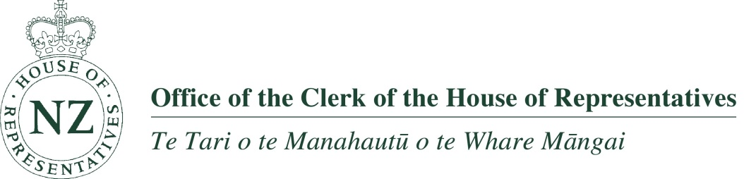

ROLE DESCRIPTION

Role: Parliamentary Officer (Kiri Āwhina i Te Kaiwhakahaere)

Group: House Services

Section: Ngā Rātonga Reo Maori

Background: Te Kaiwhakahaere – Ngā Ratonga Reo Māori is a member of the House Services Group which delivers core secretariat services for the House, its presiding officers and members. The group:

- provides advice and support services for the proceedings of the House
- provides advice and supports the legislative process, and prepares bills for Royal assent when passed by the House
- publishes the written record of the House (the Journal)
- produces the report of parliamentary debate (Hansard)
- provides Te Reo Māori translation and interpretation services.

Purpose: The purpose of this role is to assist the Te Kaiwhakahaere with interpretation and translation services to the House of Representatives and select committees.

Responsible to: Te Kaiwhakahaere – Ngā Rātonga Reo Maori

Responsible for: No direct reports

Key external relationships:
Kaiwhakarite (Parliamentary Service), Te Kaumātua (Adviser to the Speaker) and Tūhonohono (cross parliamentary employees group with a Māori focus), members of Parliament, General Manager, Parliamentary Service, Speaker, Cultural Adviser to the Prime Minister and Governor General, CEO of Te Taura Whiri I Te Reo Māori, party chiefs of staff and whips, Māori members of Parliament, executive assistants, external colleagues.

Principal Accountabilities

Accountabilities | Expected results
Te Reo Māori language services
- To interpret from Māori to English and vice-versa, as required, during the sittings of the House and, as required, select committees.  - Provides assistance to Te Kaiwhakahaere with the management of operations of Māori language services, through a pool of contractors  - Contributes to development of parliamentary policy relating to Māori language services. | - Te Reo Māori services are delivered in accordance with Standing Orders, Speakers’ rulings, established practice, professional standards, and Māori language conventions  - The transcription and translation of debates of the House and select committee proceedings from Māori to English and vice-versa, are provided in a timely fashion and to a high standard.  - An interpreter is available for the House at all sitting times and to select committees as required  - Translation and transcription service is available as requested  - Potential issues in the House and its committees that are likely to require interpretation and/or translation are identified and resourced  - The use of Te Reo Māori in official parliamentary signage, publications, and on the parliamentary website is validated  - Advice which meets the expectations of the receiver, on the use of Te Reo Māori is provided to the Speaker, members of Parliament, the Clerk, the General Manager Parliamentary Service, and other key stakeholders as required.
Policy development
- Provide assistance and contribute to development of parliamentary policy relating to Māori language services as the subject matter expert. | - Advice which meets the expectations of the receiver, on the use of Te Reo Māori is provided to the Speaker, members of Parliament, the Clerk, the General Manager Parliamentary Service, and other key stakeholders as required.

Specialist skills, knowledge and experience

- Has proven experience in interpreting and transcribing from Te Reo Māori to English; and translating from Te Reo Māori and vice-versa, as well as editing Te Reo Māori text and transcripts at this level
- Possesses well developed oral and written communication skills, and fluency in both Māori and English not only at hau kāinga level but at this level as well
- Has a high awareness of iwi and hapū dialects and tikanga
- Has strong iwi networks
- Represents the Office externally in a way that engenders confidence in the Office
- A knowledge of parliamentary procedures and practice or the ability to quickly acquire such knowledge
- A strong commitment to quality and accuracy
- Excellent interpersonal and relationship skills
- A strong service focus.

Qualifications
- Has Te Tāūnga Tohu i te Matatau ki Te Reo Māori - official Māori interpreters and translators licence from the Māori Language Commission or an equivalent recognised tertiary qualification.

Dimensions of the role

- There are no HR or financial delegations for this role.
March 2015

